

Open Education Resource (OER)
Flipping the Classroom With
MOODLE
Work done as part of AICTE approved FDP on Use of ICT in
Education for Online and Blended Learning

RC ID and Group Number: RC1192_011
Team Leader: Dr. Mr. Jasbeer Singh Siddhu
Team Member: Mr. Shaikh Mubeen
Team Member: Mr. Shatalwar B. J.

IDP in Educational Technology, 2018.
OER Submission Example by IDP in Educational Technology, IIT Bombay, is licensed under the Creative Commons Attribution-ShareAlike 4.0 International License. You are free to use, distribute and modify it, including for commercial purposes, provided you acknowledge the source and share-alike. To view a copy of this license, visit http://creativecommons.org/licenses/by-sa/4.0/
Table of Contents

Sr. No. | Title |  | Page No.
1. | Open Education Resource: Flipping the classroom with MOODLE |  | 1-5
 |  | 1.1 About the OER | 4
 |  | 1.2 Learning Objectives | 4
 |  | 1.3 Helpful Documentation for Tool Use | 5
2. | Section 2: Design Decisions |  | 6-7
 |  | 2.1 Nature of Decisions taken | 6
3. | Section 3: OER Description |  | 8-20
 |  | 3.1 Active OER | 8
 |  | 3.2 Lesson Settings | 9
 |  | 3.3 How to use this OER | 15
 |  | 3.4 Best Practices with Lesson Activity | 19
4. | Section 4: Evaluating Effectiveness of OER |  | 21-22
 |  | 4.1 Effectiveness at the student level | 21
 |  | 4.2 Effectiveness at consumer level | 21
5. | Section 5: Consolidated Log of Team Work |  | 23-23
6. | Section 6: Building a Community of MOODLE and Flipped Classroom Adopters |  | 24-25
 |  | 6.1 Possible Sources for Community Building | 24
 |  | 6.2 Plans for Community Building | 25
7. | Works Cited |  | 25-25

RC ID and Group Number: RC1192_011
Team Leader: Dr. Mr. Jasbeer Singh Siddhu
Team Member: Mr. Shaikh Mubeen
Team Member: Mr. Shatalwar B. J

Open Education Resource (OER)
Prepared By
RC ID No.1192
Team No. 011
Team Leader Name:
Dr. Jasbeer Singh Siddhu
PhD (Composite Materials)

Team Members Name:
Mr. Shaikh Mubeen BE (Mech) , ME(MPE).
Mr. Shatalwar B. J. BE (Mech) , ME(Mech)


MGM’s College of Engineering
Nanded, Maharashtra.

Chapter No. 1
Flipping the classroom with MOODLE

  - About the OER
The open education resource is a collection of MOODLE Lesson activities that are useful as out-of-class activity while flipping the classroom. There are three lessons as part of this OER, and each deals with an aspect related to Concept Maps. Concept mapping is a technique that is useful across domains and can be a useful tool for: Knowledge Integration and Summary.
- OER is downloadable from: https://jasbeersingh.music.blog/
And also available at https://jasbeersingh.moodlecloud.comTarget Audience: Third year Engineering Students (For Computer Science, Information Technology and Electronics and telecommunication Engineering domain)
- Tags: Flipped Classroom, MOODLE, Concept Map, Educational Technology, engineering Students
- OER developed in MOODLE CLOUD 2.3
- This resource is licensed under CC-BY-SA ver 4.0. You are free to use, distribute and modify it, including for commercial purposes, provided you acknowledge the source and share-alike. To see more details about the license visit http://creativecommons.org/licenses/by-sa/4.0/
  - Learning Objectives
After using this OER, learner will be able to:
- Identify the characterizing features of a automobile
- Design and Implement different application.

Course Objectives of Automobile Engineering
1. This course is designed to understand the basic concepts of Automobile and its
Components.
2. To understand the recent advances in the Automobile Technology.
Course Outcomes:
1. Students will be able to demonstrate and explain various automobile systems.
2. Students will be able to explain the importance of various important systems like
differential, steering, Brakes, Suspensions etc.
3. Students will be able to explain principle of operation, construction and
application of latest sensor Technology used in automobiles.
  - Helpful Documentation for Tool Use
- For design and development of Lesson Activity in MOODLE (an Open Source Tool)
- For use of Jing (a Freemium Tool)
- Use of Wordpress , Moodlecloud and Screencaste Tools
Chapter No. 2
Design Decisions

2.1 Nature of Decisions taken

The design decisions involved in the creation of this OER were of broadly three types:
- Content Decisions
- Pedagogic Decisions
- Technology Decisions
1 Content Decision
The content decisions related to:
- Earmarking specific segment to be covered – Contents on DSCA –What, Why and How?
- The research papers/publications and other materials to be provided – DSCA Page, Theory, concept, algorithm and application of DSCA Subject and apply it in real life.
2 Pedagogic Decisions
Typically in a flipped classroom strategy, there are two segments
- Out-of-class segment and
- In-Class segment.
The out-of-class segment requires student to refer to some given material (Video, Text, Xerox material, PPTs and animation using Blenders etc) and form an understanding about the concepts that are relevant. In terms of concept marking the pedagogic decisions that were taken for the Out-of-class segment related to:
- Cognitive Levels of Questions to be asked along with the resources – Mostly Recall/understand to Apply level question for out of class and Create & Evaluation Level question for In-class
- Assessment Strategies – Multiple choice questions for out of class, Team-Pair-Solo strategy , think-peer-shear strategy, roll play and Game strategy for in-class
3 Technology Decisions
While developing the Out-of-Class and In-class activities, the major technology decisions taken were:
- Tool to be used for creating Screen-O-Matic using screen cast – Jing software , as it had a time limit of 10 minutes and provided option for creating videos as .mp4 files that can be directly played from browser and also upload it on You tube to share publically.
- MOODLE Lesson Activity for setting up Out-of-Class segment as it allowed guided self-learning.
- Out- of –Class activity help students to understood concept more clearly.
- In-Class Activity helps the students to reach at Evaluate Level.
- Students will score more Marks in final examination due to Out-Of-Class and In- Class Activity.
- Students will also give feedback on Facebook, whatsapp group, wordepress and moodlecloud sites.
- We create more interactive teaching learning, video dialogues using flipped class room and online open education recourses courses.

Chapter No. 3
OER Description
3.1 Active OER
For checking the active OER, you may access the Guest Course – “FDP201X_OER_submission_JSS_ OER1192_011” in the IDP-ET Moodle
(https://jasbeersingh.moodlecloud.com).
The guest password required for exploring the activity is:
The guest password don’t required only other users can view the contains not attempt the quiz in guest login.
Guest Login
User Site Address: https://jasbeersingh.moodlecloud.com
User Name: jasbeersingh
Password: No Password required

If you can see the contains then use moodlecloude username and password as follow
Administrator Log in
User Site Address: https://jasbeersingh.moodlecloud.com
User Name: jasbeersingh
Password: Sidhu1971

Login page will appear like this:


3.2 Lesson Settings
Screenshots 1-3 shows the general settings of a Lesson. This is same for all the lessons. If there are variations, then they are duly noted under each description
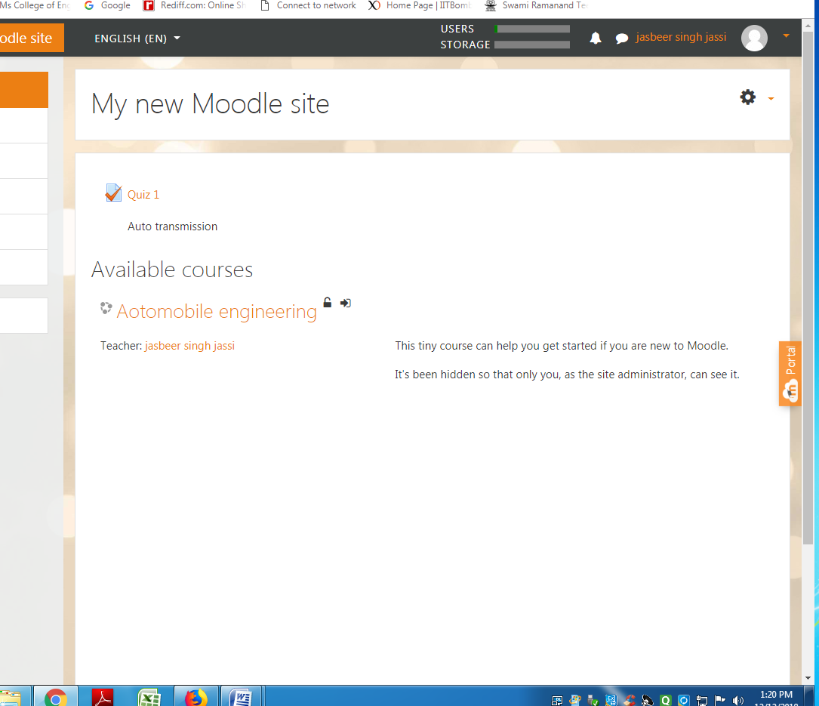
.
Screenshot 1: General and Appearance setting in MOODLE
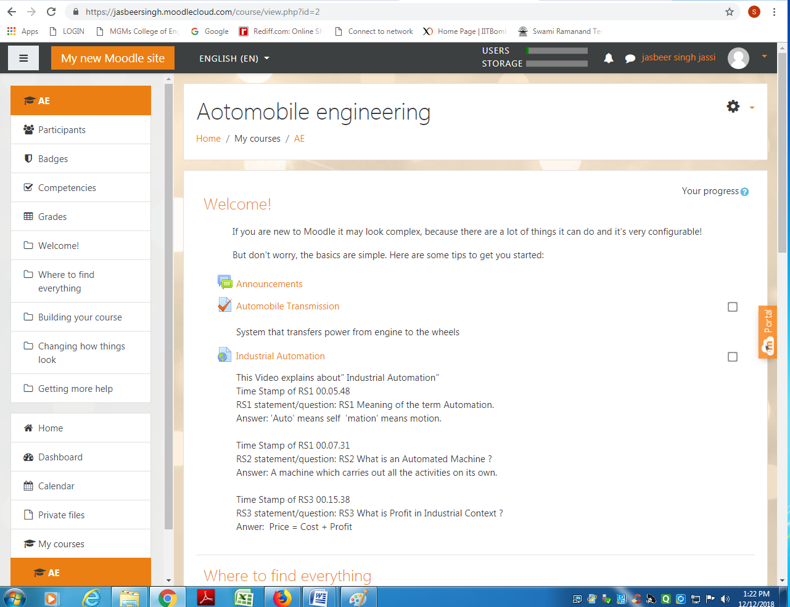

Screenshot for course details:
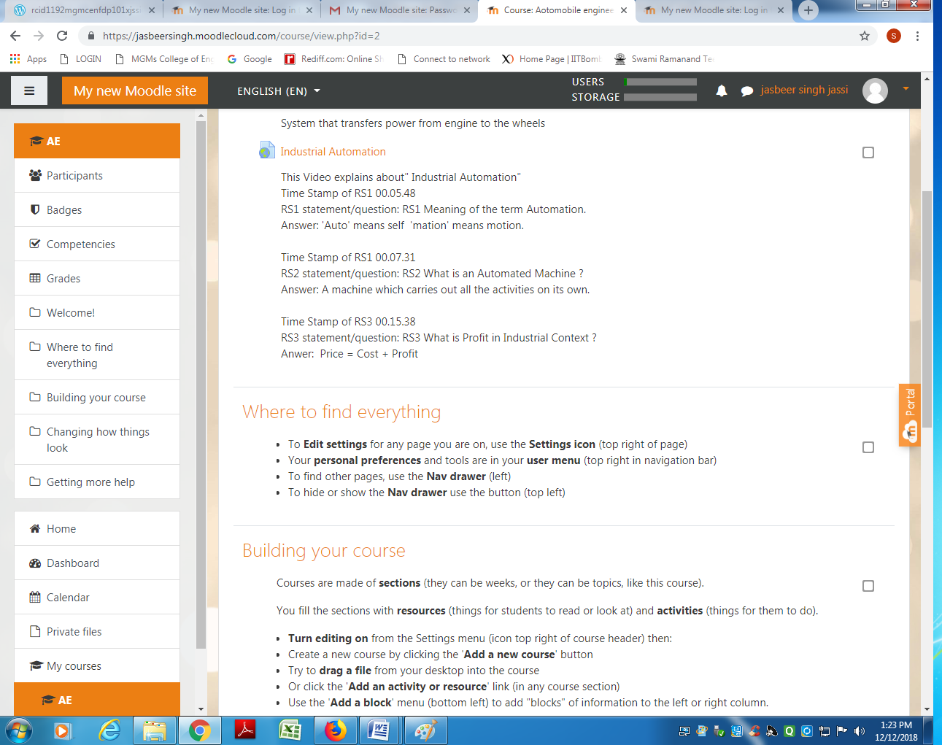
Screenshot 2: Prerequisites, Flow of Control and Grading
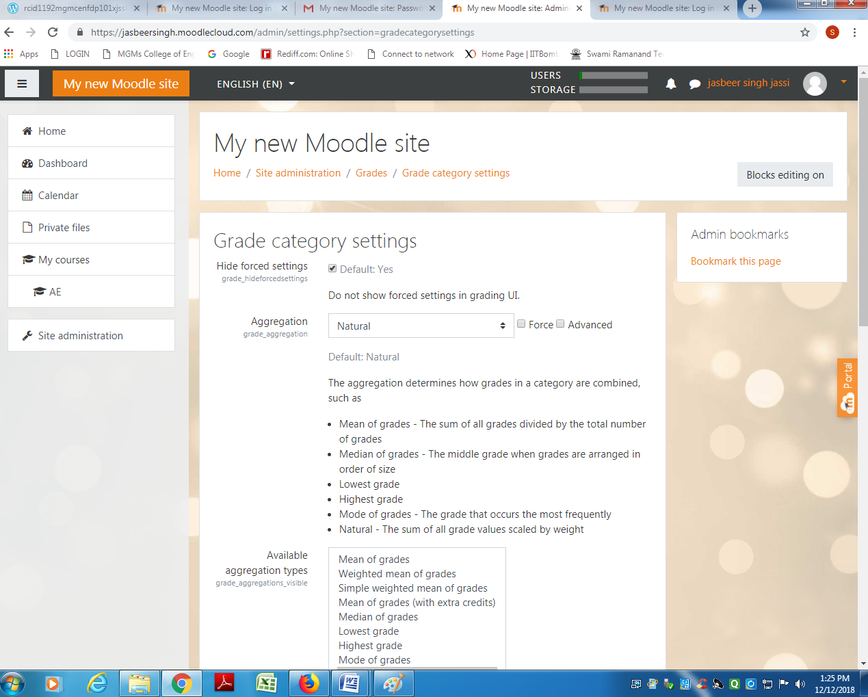
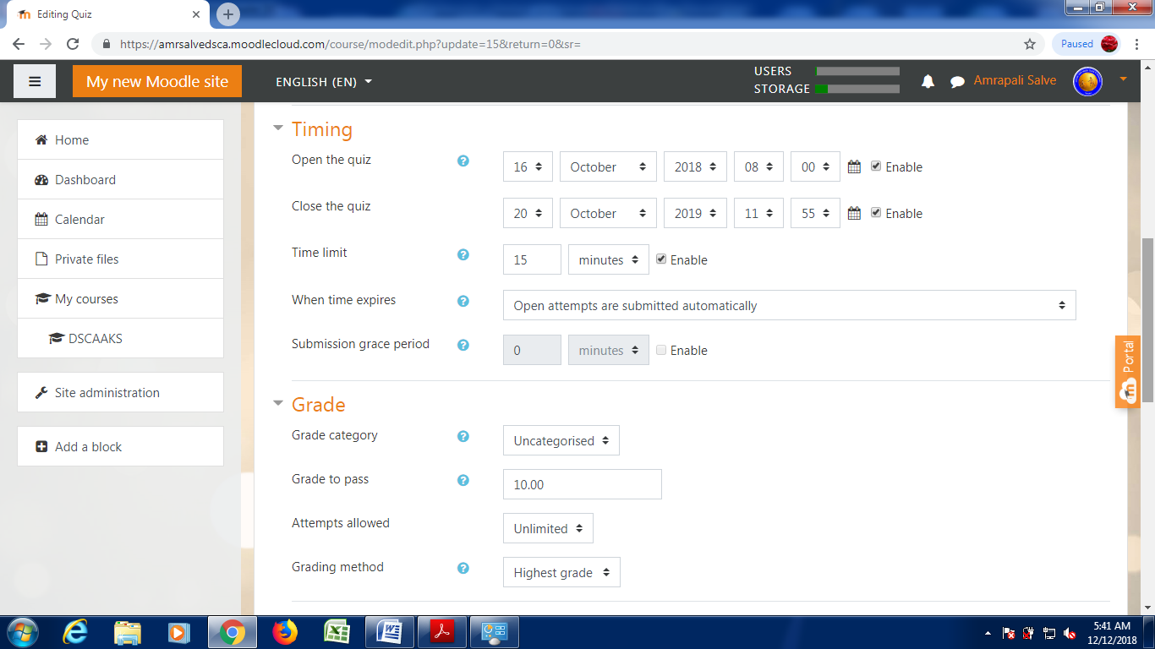
You can create sequencing of the flow by ensuring that prerequisites for successive lessons. For e.g., “DSCA – What?” is a prerequisite for “DSCA – Why?” and “DSCA – Why?” is a prerequisite for “DSCA – How?”

Screenshot 3: Access Restriction and Completion Settings
Once again access restriction settings can ensure that a proper sequence has been followed in the access of lesson (if Prerequisites are not mentioned).
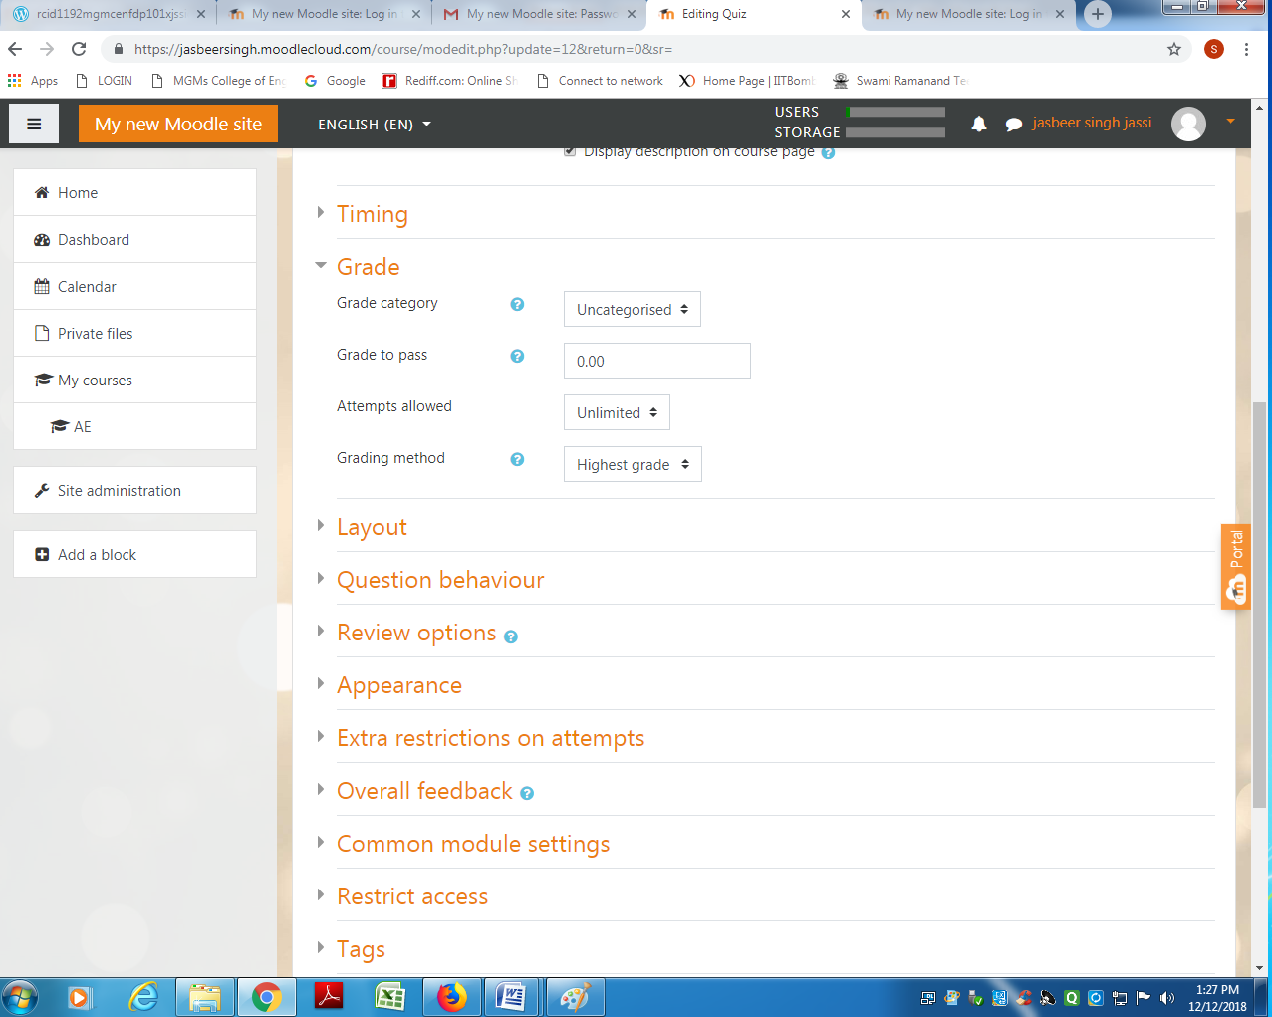

Screenshot 4: Contents of Lesson – “DSCA – What?”
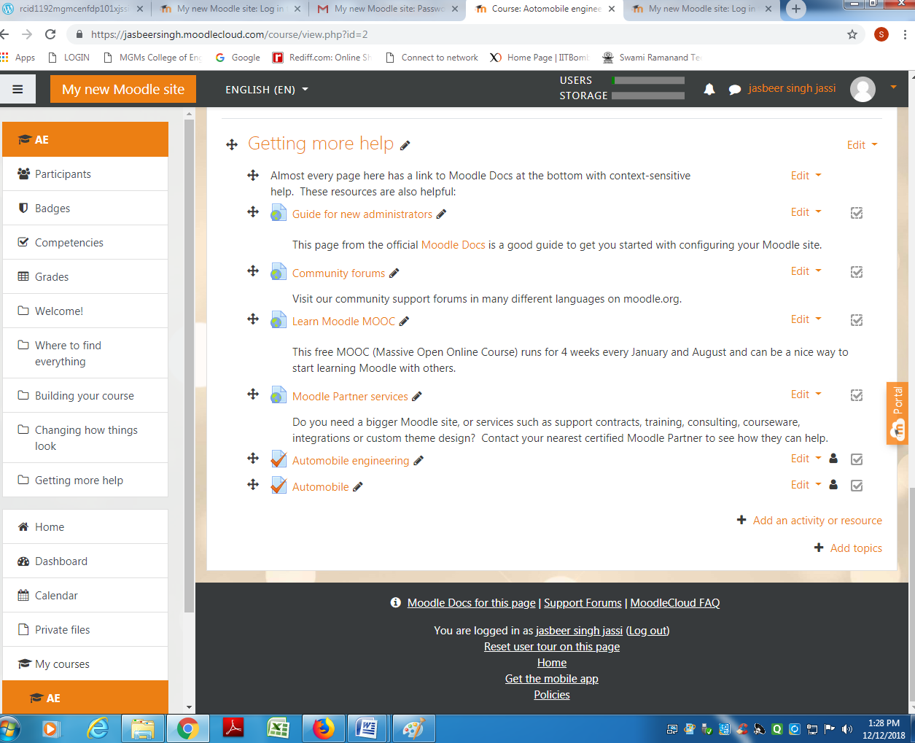
Screenshot 5: Setting up Content in the Lesson
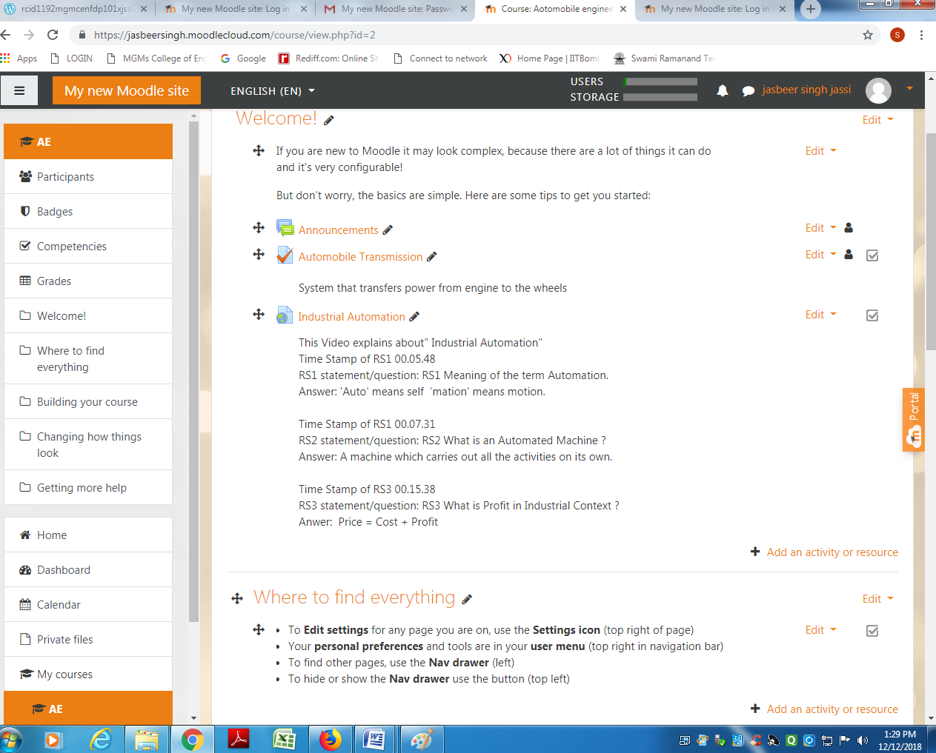

Screenshot 6: Preview of the created content
Screenshot 7: Creating MCQ and branching instructions inside the lesson
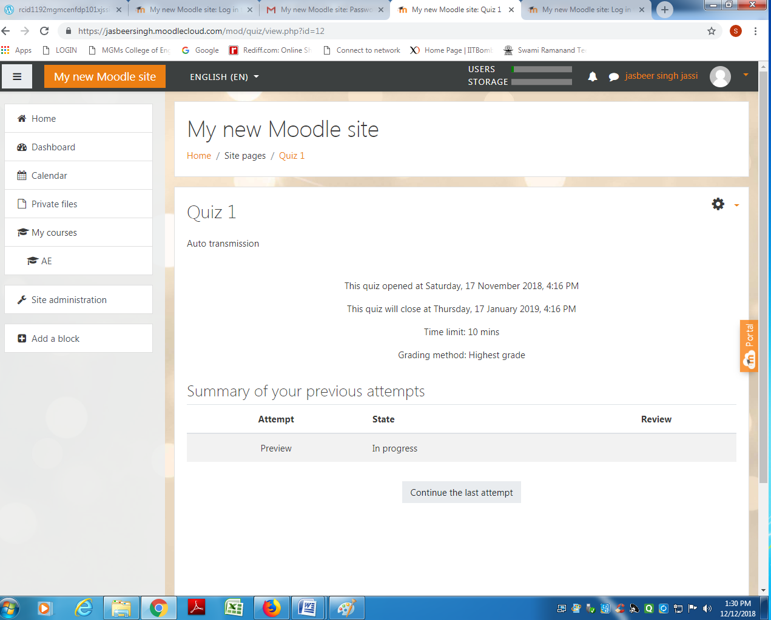

Screenshot 8 : Student view of MCQ
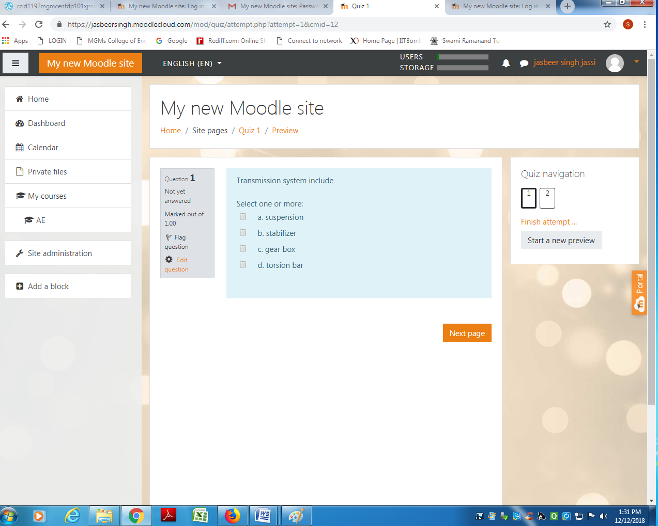

Screenshot 9:- Students Grading Summary
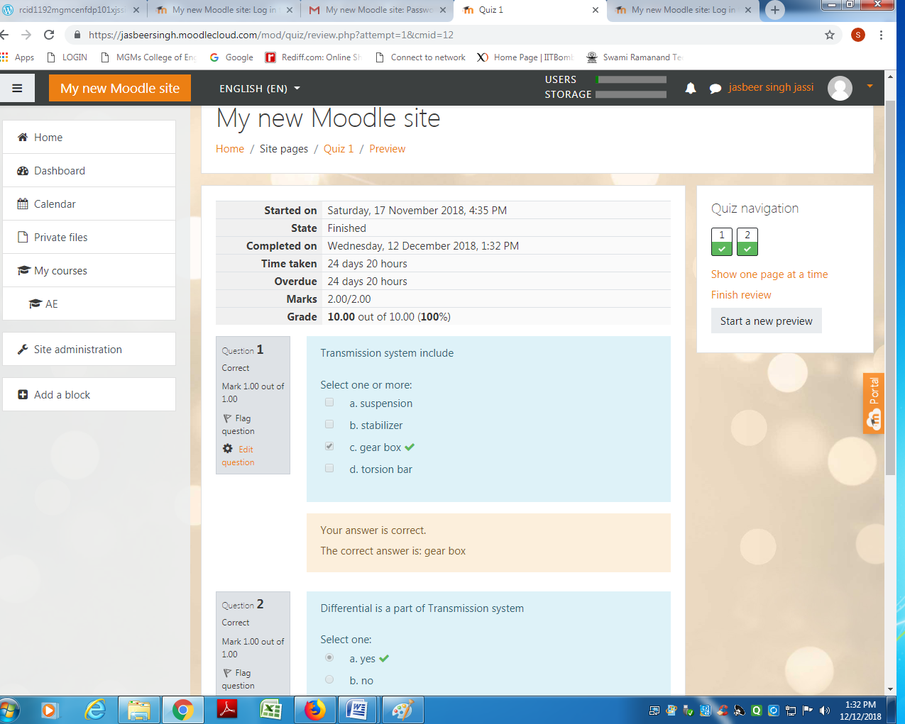

3.3 How to use this OER
For using this OER, please ensure that you have admin permission in your MOODLE
Course (needed for importing activities). Else ask your administrator to restore this backup in your course.
Step 1: Download the set of 3 lessons (OER) from https://jasbeersingh.moodlecloud.com
Step 2: Go to the MOODLE course where you want to import this lesson. In the Administration section click “Restore”
- To see the contents of DSCA subject
- also check all the permission of the current course
- date of activation of the course
- Learn the details using NPTEL Video, Screen caste Created video, PPTs, Animation, pdf material etc.
- Evaluation based on quiz, assignment etc.
- Grades of the course
- Feedback of student and teachers.
Step 3: Drag and drop the three files into the “Files” area and click restore
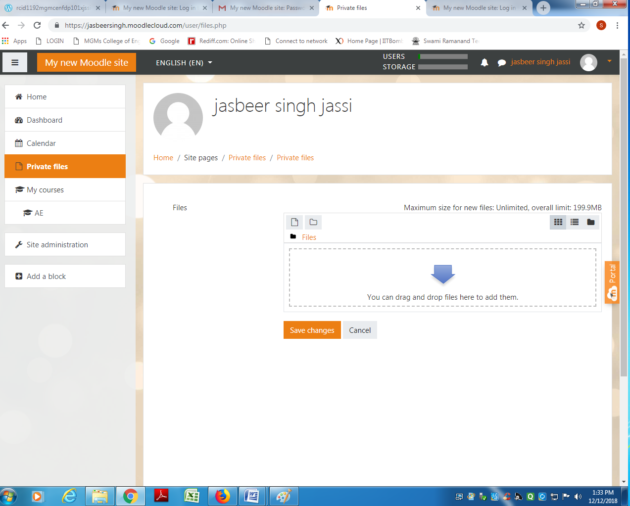

Step 4: Verify the contents of the restore by going back to the lesson
Quiz feedback:
Step 5: Assignment solve online: answer to be submitted in any file format or type here
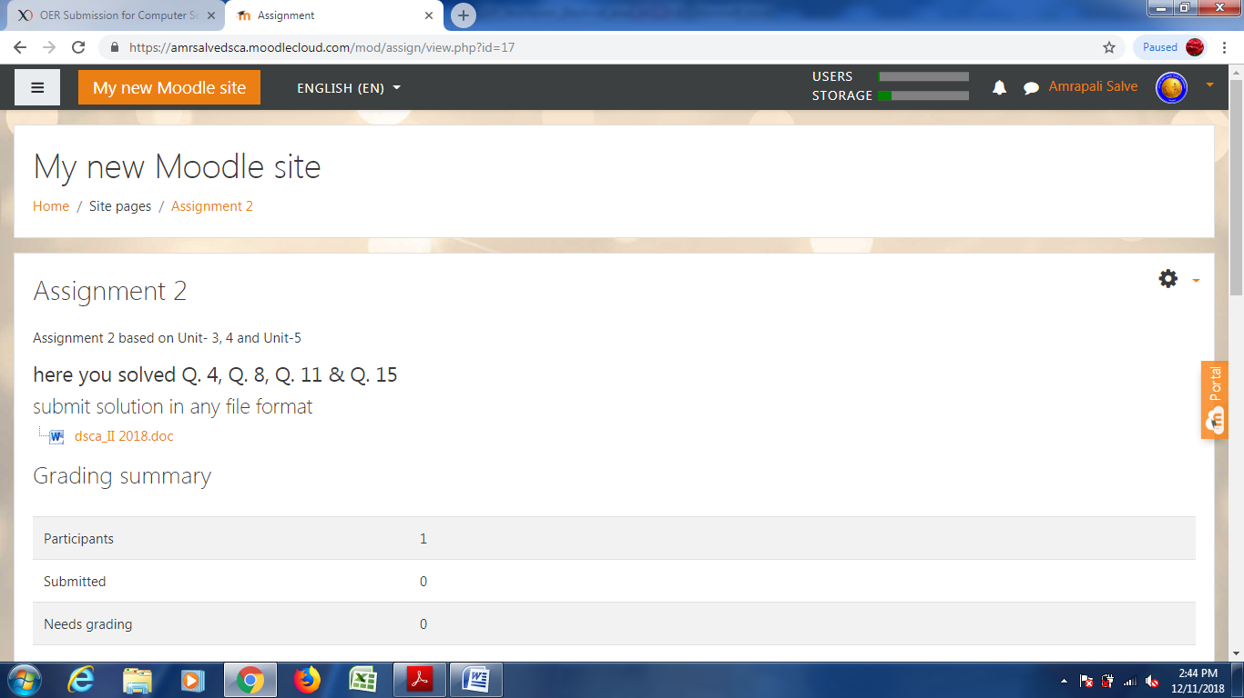
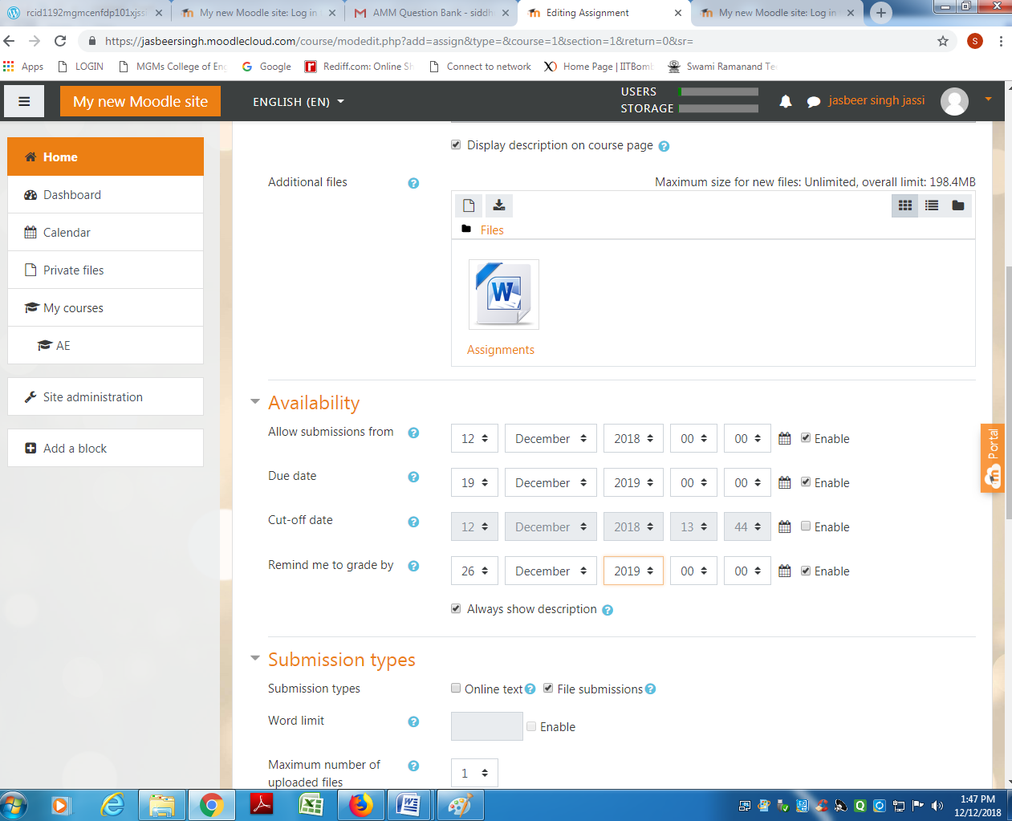
Step 6: After verifying, post the instructions to your students to complete the lesson activity
Before the next class using MOODLE forums.
Step 7: Before start of the next class please go and check the reports (see fig below) to see how students performed.

Additionally, if there are some common errors made by students, you may start the face-to face session with a Peer Instruction question to elicit the misconception and resolve it.
3.4 Best Practices with Lesson Activity

Here are some of the best practices from our experience on using this Lesson Activity in classroom:
- Provide this activity at least 1 week in advance.
- Provide minor incentive (marks) for completion of the activity.
- Ensure that there is a tangible output at the end of out-of-class activity to ensure learners are interested (E.g. For the lesson “Data Structure and Computer algorithm – How?” students had to create concept DSCA for two videos.)
- It would be good if the screencasts and resources were separately available in a “Resources” folder in the MOODLE course itself. This will take care of common cribs related to “website not available”, “resources not accessible” etc.

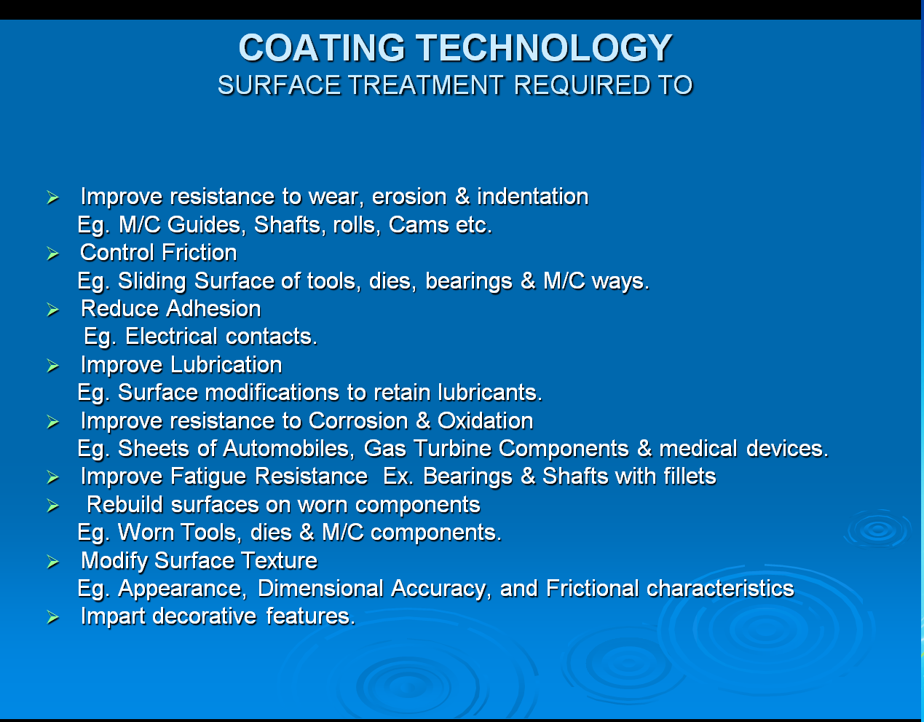

- Provide NPTEL Video Link with Reflection Spots
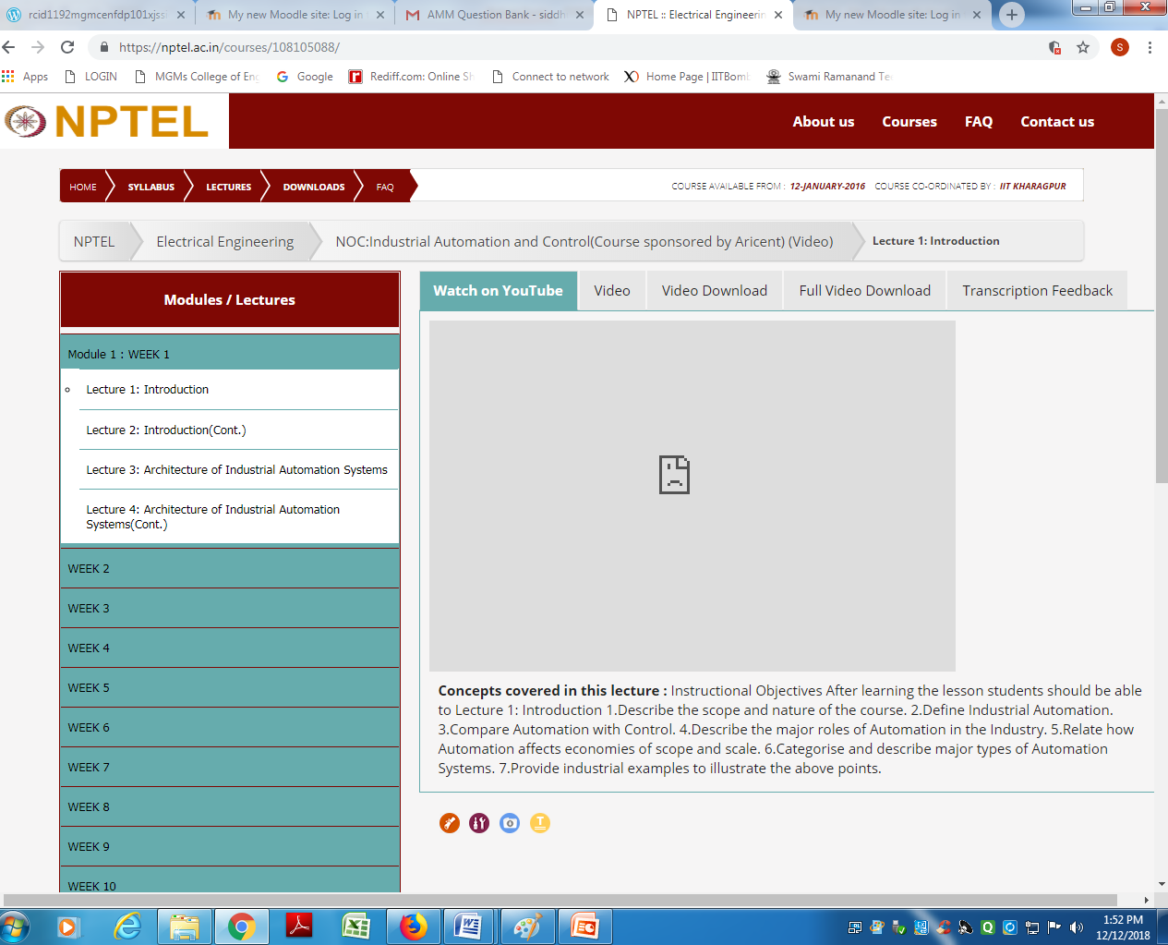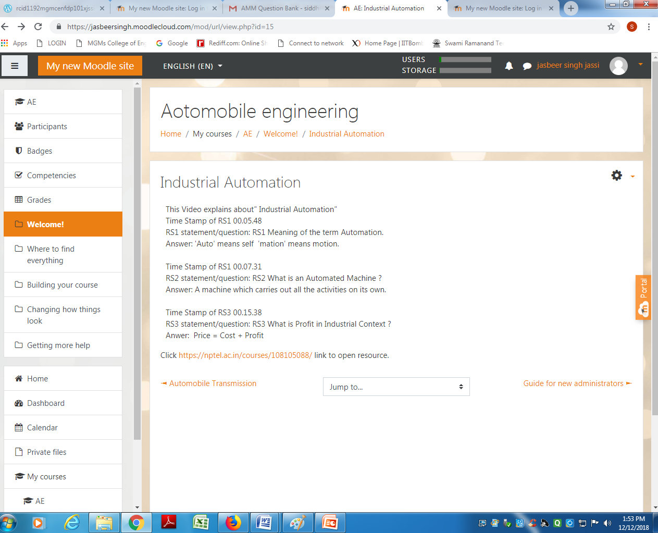

Chapter No. 4
Evaluating Effectiveness of OER

The OER effectiveness can be assessed at two levels:
- At the student level
- At the consumer level
4.1 Effectiveness at the student level
Effectiveness at the student level involves metrics related to student access of the resource and student learning. The Moodle lesson report can be used to evaluate this effectiveness, with the report showing the total number of students who accessed the reports (along with time) and their marks (based on their answers to MCQs). Additionally there is an option for teacher to grade essays and these marks also will be calculated if needed.
4.2 Effectiveness at consumer level
OER consumers are typically teachers who want their students to learn concept mapping. Linking a survey on three main constructs – Ease of Use, Concept Coverage and Concept Complexity, can help in identifying the effectiveness of this OER at consumer level. This has to be done as a follow-up activity.
Implementing Survey
Thus every user who downloads this resource will be asked their email address and as a follow up the survey will be sending to their email address.
Observe the how many student appear for the quiz
How many students solved assignments?
How many students implement programs?
How many feedbacks had received?
Survey Questions
Construct Question Scale Ease of Use
Sr. No. | Construct | Question | Scale
01. | Ease of Use | I found it easy to download the Lesson Activity | Strongly Disagree to  Strongly Agree (5-point  Likert Scale)
01. | Ease of Use | I found the instructions to setup the Lesson Activity useful in setting the activity in my Course | Strongly Disagree to  Strongly Agree (5-point  Likert Scale)
01. | Ease of Use | I was able to successfully create Lesson in my own course | Strongly Disagree to  Strongly Agree (5-point  Likert Scale)
02. | Concept Coverage | The Lesson covers the required concepts related to concept maps that I need for my Course | Strongly Disagree to  Strongly Agree (5-point  Likert Scale)
03. | Concept Complexity | The content inside the Lesson is too complex for my students to understand | Strongly Disagree to  Strongly Agree (5-point  Likert Scale)

Chapter No. 5
Consolidated Log of Team Work
The consolidated log of team work is as shown below:
Sr. No. | Activity | Team Members | Amt. of Time | Additional Log if Any
1. | Discussion | Team Leader: Dr. Mr. Jasbeer Singh Siddhu | 2 Days
1. | Discussion | Team Member: Mr. Shaikh Mubeen  Team Member: Mr. Shatalwar B. J | 2 Days
2. | Tool Exploration | Team Leader: Dr. Mr. Jasbeer Singh Siddhu | 4 Days | Plan uploaded in wordpress & moodlecloud
2. | Tool Exploration | Team Member: Mr. Shaikh Mubeen  Team Member: Mr. Shatalwar B. J | 4 Days | Plan uploaded in wordpress & moodlecloud
3. | OER Creation | Team Leader: Dr. Mr. Jasbeer Singh Siddhu | 4 Days | Plan uploaded in moodlecloud and wordpress
3. | OER Creation | Team Member: Mr. Shaikh Mubeen  Team Member: Mr. Shatalwar B. J | 4 Days | Plan uploaded in moodlecloud and wordpress
4. | OER  Documentation | Team Leader: Dr. Mr. Jasbeer Singh Siddhu | 2 Days | Create using MS word and convert it into pdf file format
4. | OER  Documentation | Team Member: Mr. Shaikh Mubeen  Team Member: Mr. Shatalwar B. J | 2 Days | Create using MS word and convert it into pdf file format
5. | Individual  Reflection (Diary  Logging) | Team Leader: Dr. Mr. Jasbeer Singh Siddhu  Team Member: Mr. Shaikh Mubeen  Team Member: Mr. Shatalwar B. J | 2 Days | Review Comments in Wordpress & IITBomabyX
6. | OER Evaluation | Team Member: Mr. Shaikh Mubeen  Team Member: Mr. Shatalwar B. J | 2 Days | Edits made in wordpress, moodlecloud and IITBombayX
6. | OER Evaluation | Team Leader: Dr. Mr. Jasbeer Singh Siddhu | 2 Days | Edits made in wordpress, moodlecloud and IITBombayX

Chapter No. 06
Building a Community of
MOODLE and Flipped Classroom Adopters

6.1 Possible Sources for Community Building
Some of the viable sources for building a community are:
- Teachers who are using MOODLE
- Teachers who plan to use Flipped Classroom Strategies
6.2 Plans for Community Building
The resource is already available in the webpage and its access requires the users to provide their email id. Thus there will be a list of interested users whom we can follow up using email. All the interested users can then be connected using a local Wordpress or Moodle website.

Chapter No. 07

Works Cited

- MOODLE.(12/December/2018 ) Moodle Docs. [Online]
- Moodlecloud site: https://jasbeersingh.moodlecloud.com
- Wordpress Site: https://jasbeersingh.music.blog/
- Techsmith. (2018) Jing. [Online]. https://www.techsmith.com/tutorial-jing.html

