Indian Institute of Technology Bombay
IDP in Educational Technology
Instructor Resources
Resource – Peer Instruction Activity constructor | Version 1.0, Feb 2014
Download from: www.et.iitb.ac.in/TeachingStrategies.html | Released under: Creative Commons-Attribution 4.0 license

Constructing Peer-Instruction questions of various types for different purposes
Peer-Instruction questions can have a variety of goals, and can be formed using different pedagogical strategies. Questions below contain different possible goals and instructor can have. The questions also contain brief ‘how-tos’ for writing Peer-Instruction questions for each goal.

Part 1 – Plan your PI activity
- Choose a subject and topic that you will be taking in the next/current semester.
Subject: Automobile Engineering.
Topic: Automobile Suspension

Part 2 – Type of PI Instruction

For each goal given below, write a Peer-Instruction question in your chosen topic. Each question must contain the question ‘stem’ along with 3-5 choices. See examples on slides of “Online_PeerInstruction_Set3.pdf “in the section “Types of Peer-Instruction questions” and “When to use Peer-Instruction questions”.

A. Goal: Conceptual reasoning “one right answer” questions.
How to write the PI question: Write conceptual questions which can be answered using verbal arguments, logical reasoning, proportional relationships, and so on. Avoid questions that need numerical calculations.
Examples (note that these are merely ideas – you have to write the full question and choices):
Describe a scenario such as a process or a phenomenon. Ask what would happen to the objects in the scenario or the variables in the process if a certain stimulus were applied.
·Does it increase / decrease / stay same?
·Move left / right?
·Compare A & B –which is greater /less same?

Why a suspension is needed in an automobile ?
- It helps in Comfort, Contact and Control.
- It helps in engine fuel milage.
- It supports the parts under the chassis
- It helps in propulsion of automobile.

Time Stamp :1.14

Video url: https://www.youtube.com/watch?v=jOiOO7qloXQ

B. Goal: Discussion “no one right answer” questions
How to write the PI question: Write questions which genuinely admit multiple possible answers, say while making design choices, modeling systems.
Examples (note that these are merely ideas – you have to write the full question and choices):
·If you could choose only one X, which would it be?
·What do you think is the reason for Y?
·If you had to make a decision for Z, what would it be?
Dampers are required in Automobile suspension, because……….

- Without dampers vehicles continue to roll or pitch.
- It ensure smooth and soft ride.
- It cushion out at the time of acceleration and braking.
- They are damping the vibrations in the vehicle resulting out of wavy surfaces.

Time Stamp :4.47

Video url: https://www.youtube.com/watch?v=jOiOO7qloXQ

C. Goal: Predict an outcome (e.g., of an experiment, or a program)
How to write the PI question: Describe the experiment. You can partially show it (not the result) using a demo, video, simulation. Ask students to predict what would happen if something were changed. Choices should indicate specific possible outcomes.
Examples: If P were changed, what would happen to Q? (You can ask along following parameters) (note that these are merely ideas – you have to write the full question and choices):
i)…becomes bigger/ smaller
ii)… changes brightness – increase / decrease / stay same
iii)… changes shape to A / B / C
iv)… moves along path A/ B/ C …
After voting, during discussion phase, ask students to give reasons along with their choices. These are excellent questions to elicit students’ wrong reasoning patterns.
If dampers are removed , what will happen to the working of suspension .

- Vibrations will get amplified dangerously.
- Vehicle will continue to move aat higher speeds.
- Rolling and Pitching of vehicle will try to reach its resonance limits.
- At higher speeds Vehicle may not vibrate.

Time Stamp :5.00

Video url: https://www.youtube.com/watch?v=jOiOO7qloXQ

D. Goal: Embed reasoning in answers
How to write the PI question: The question describes a phenomenon or a situation. Choices include not just what happens but also possible reasons including plausible but wrong reasons. Different choices can correspond to multiple reasons for the same outcome.
Examples (note that these are merely ideas – you have to write the full question and choices):
·…slower since gravity is acting against it;
·… slower since there is friction
Dampers, if not provided may introduce a rough ride …

Reason: Springs absorb the shock due to roughness in the track the shock is absorbed and the spring continues to vibrate, the role of damper here is to damp these vibrations and make the ride a smoother one.

Time Stamp :4.47

Video url: https://www.youtube.com/watch?v=jOiOO7qloXQ

E. Goal: Reason using representations
How to write the PI question: Give one representation of a scenario or a process. Ask students which of the choices best describes it in a different representation. The question as well as the choices could contain different representations such as diagrams, graphs, equations, words.
Examples (note that these are merely ideas – you have to write the full question and choices):
·Which graph best represents the equation ….?
·For the given configuration, what is the pattern of variable X?
·What is happening to variable Y at this point in the graph?
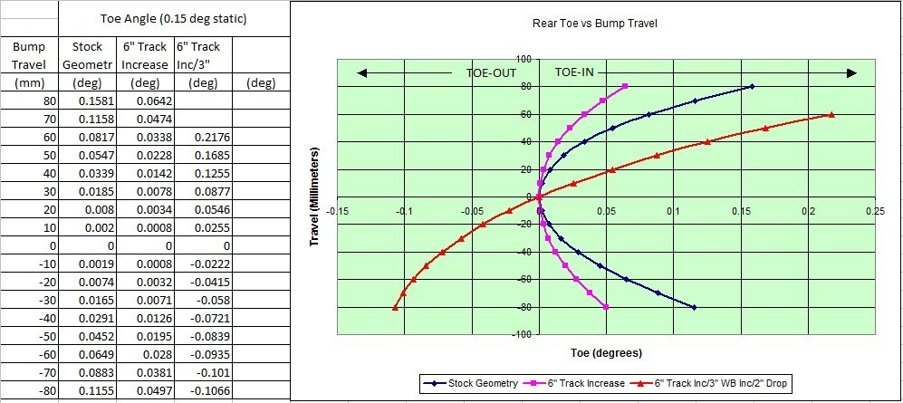

F. Goal: As a stepping stone to problem-solving
How to write the PI question: The goal of this PI question is to help students through the steps of a complex problem without solving it for them yourself. Break up the analytical problem into steps. Convert one or more step into a PI question. This step can involve choice of principles needed to solve the problem, drawing graphs / diagrams needed to solve the problem, setting up of the mathematical equations, etc. See the example of the mid-sem question in main workshop slides, how it was converted from a full problem to a series of PI questions.
In designing of suspension following Elements are of importance

- Springs
- Dampers
- Links
- Strut etc.

Depending upon the Sprung Weight of the Vehicle yese need to be designed.

Time Stamp 7.45

Video url: https://www.youtube.com/watch?v=jOiOO7qloXQ

G. Goal: Recall point from previous lecture
How to write the question. These are easier questions than some of the above. The goal is to recap ideas from the previous lecture which are needed in today’s class. Give as opening activity of a class. Can replace traditional “Summary of last class” slide. Helpful in getting students to settle down. In the question, ask students to identify definition or give straightforward application of concepts.
Activity 1 :Take ride on a Bullock cart , share the ride experience of your ride in 500 words.
Activity 2 :Take ride on a Tractor , share the ride experience of your ride in 500 words
Activity 3 :Take ride in a car , share the ride experience of your ride in 500 words

This wil give you an insight into the importance of a suspension system in an automobile.

Video url: https://www.youtube.com/watch?v=jOiOO7qloXQ

H. Goal: Survey questions / personal opinion
How to write such PI questions: Use such questions as -
a) a means to get group information about the class (Examples: how many know programming to level X, level Y …)
b) feedback for instructor on own teaching practice (Examples: pace too fast/ slow, exam difficult/ easy, last lecture understood / not)
c) get an opinion of what students think about an open-ended issue (Examples: energy, climate change, policy …)
Feedback of the students they will share and discuss about the significance iof Suspension in an Automobile.

Part 3 – Challenges, Best Practices and Resources
Refer to the slide “Online_PeerInstruction_Set5.pdf”

Part 4 (Optional): Conduct an education research study
If you are interested in determining the effectiveness of your implementation, beyond informally asking a few students for their opinion, then contact convener.et@iitb.ac.in . Research scholars from the IDP-ET will be happy to work with you to structure an education research study for your PI activity.

